Level 1: PC Tower Case

Outline

Learn about the internals of a standard PC case by examining physical samples and selecting and labeling images found on-line. Gain deeper knowledge by researching and reporting on specific components.

Questions

Find one (or more) images that clearly show the internals of a PC Tower Case.

(i.e. Google images using keywords “PC Case Internals”)

Clearly label the following components (using arrows) on your image of the PC case internals:

Motherboard

Power Supply

Hard Disk Drive

Optical Disk Drive (e.g.DVD)

USB Expansion Ports

Monitor Port

Audio Ports

Ethernet Port

Cooling Fan

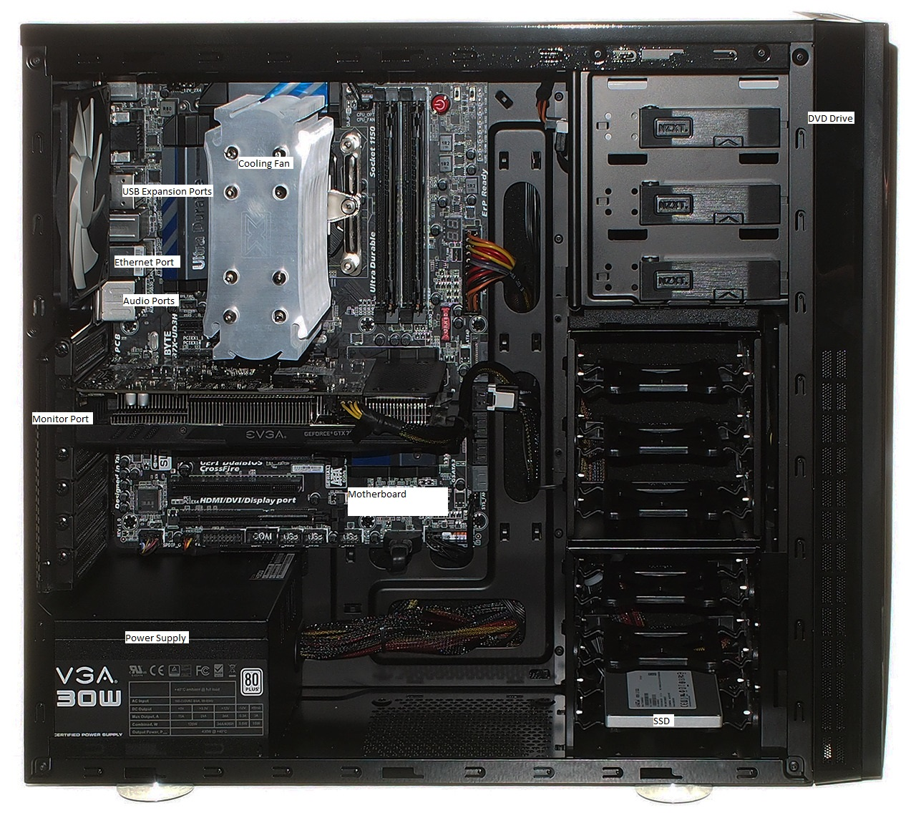

Research more in-depth about “Motherboards”. Make notes on the following:

What different versions are currently available (speed and capacity)

How the component has changed since the 1980’s

ATX and ITX motherboards are the most popular motherboard versions available, but there are other types that are available to the market. ATX motherboards tend to be much larger than ITX, and have more versatility when it comes to upgrading or replacing different components.

Research more in-depth about “Hard Disk Drives”. Make notes on the following:

What different versions are currently available (speed and capacity)

How the component has changed since the 1980’s

There are two types of hard drives that are available, and they are internal and external hard drives. Internal hard drives come in two sizes. One is for deaktops, are larger and heavier usually containing more storage. The other is for laptops, and they are smaller with usual less storage for the size. External hard drives come in all shapes and sizes, and use different connectors than SATA for being inside computers. External hard drives usually use micro usb or usb c for faster data transfer. Hard drives are slowly becoming obsolete, due to SSD’s being around 10X faster than hard drives. There are also M.2 SSD’s, which are much faster being in a M.2 port which supports 4 lanes of PCIE.

NOTE:

Download the on-line version of this module (from the class GitHub repository)

Questions for Level 2 and Level 3 are in the on-line version of this module

Provide your answers in a MS Word, PowerPoint, or equivalent format

Upload your answers to your personal GitHub repository

Level 2: PC Motherboard

Outline

Learn about the structure of a standard PC motherboard by examining physical samples and selecting and labeling images found on-line. Gain deeper knowledge by researching and reporting on specific components.

Questions

Find one (or more) images that clearly show the layout of a PC Motherboard.

(i.e. Google images using keywords “PC Motherboard”)

Clearly label the following components (using arrows) on your image of the PC motherboard:

CPU (and fan)

RAM Memory

Disk Drive Interface (IDE or SATA)

GPU Graphics Processor (either on-board or Graphics Card)

Sound Processor (either on-board or Sound Card)

Wi-Fi / Ethernet Network Interface (either on-board or Graphics Card)

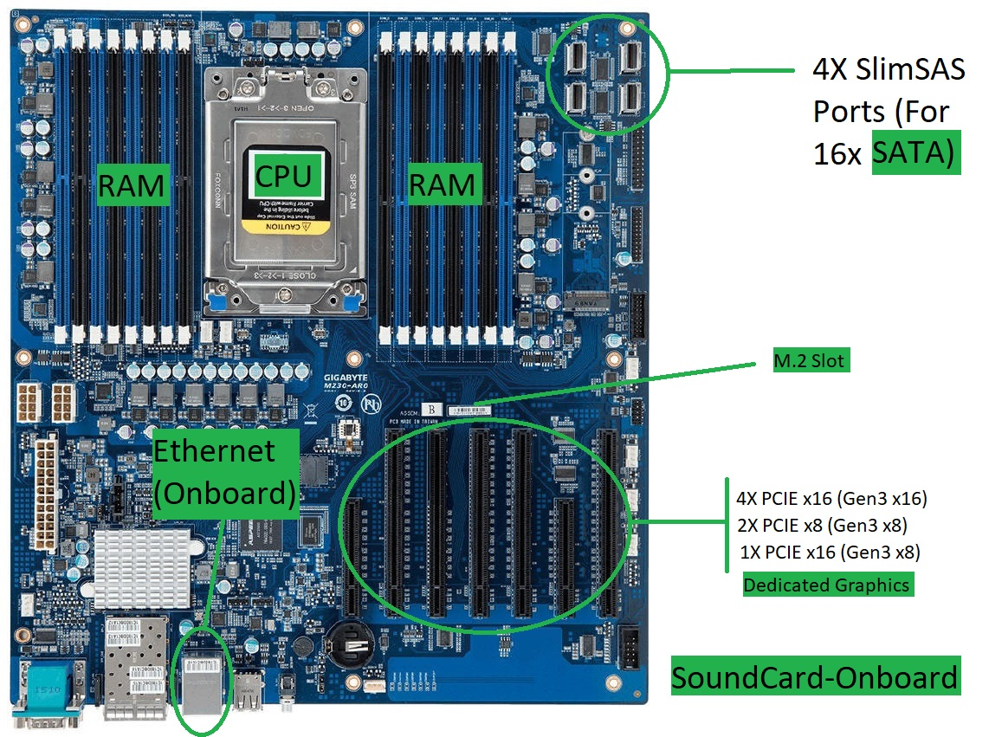

Research more in-depth about “CPU Processor Chip”. Make notes on the following:

What different versions are currently available (speed and capacity)

How the component has changed since the 1980’s

There are different generations of processors, as well as processors made by different companies. Intel is a major company for processors, as well as Ryzen and other brands. In the Intel lineup, there are currently 8th gen processors, generally with 6 cores. There are i3, i5, i7, and i9 processors. For server based processing, Intel has their xeon lineup which costs a couple thousand dollars each.

Research more in-depth about “RAM Memory”. Make notes on the following:

What different versions are currently available (speed and capacity)

How the component has changed since the 1980’s

RAM memory has risen in price over the past couple years. There are different speeds of RAM, although they do not matter as much as the amount of RAM. RAM is available in as little as 500mb, and increases to amounts like 1gb, 2gb, 4gb, 8gb, 16gb, 32gb, 64gb, 128gb, and all the way up to 256gb for the systems that can support a Terabyte of RAM. The speed comes in different values, starting at about 1666MHz, 2133MHz, 2400MHz, 3200MHz, 4266MHz, and 4600MHz.

Level 3: Peripheral Devices

Outline

Learn about how peripheral devices are connected to the back side of a typical PC tower case. Examine physical samples, select and labeling images found on-line and gain deeper knowledge by researching and reporting on specific components.

Questions

Find one (or more) images that clearly show the layout of the back of a typical PC tower case.

(i.e. Google images using keywords “Back Of PC Tower”)

Clearly label the following components (using arrows) on your image of the back of a typical PC tower case:

Power cord and power switch

Monitor Interface (VGA or DVI or HDMI)

Mouse Interface (USB or PS/2)

Keyboard Interface (USB or PS/2)

USB Ports

Audio Inputs / Outputs

Ethernet Interface

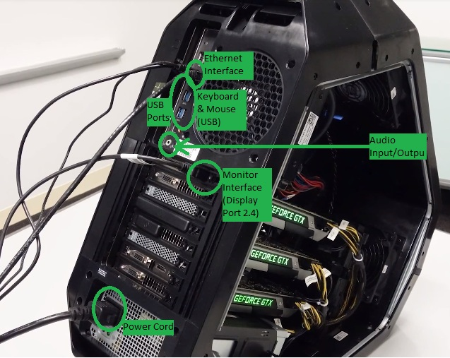

Research more in-depth about “Monitor Technology”. Make notes on the following:

What different versions are currently available (e.g. VGA / DVI, Flat Panel Technology))

How the component has changed since the 1980’s (e.g. Display Resolution, Technology)

There are different monitors available on the market today. Most popular monitors, tend to be 1080p monitors, but there are also 1024p, 1440p, 4k, 5k, 6k, and 8k monitors available on the market. The higher the resolution, the more expensive the monitor gets. But in some cases, lower resolutions can be more expensive because for gaming or 3d viewing, you’ll need a high refresh rate, which can come in 30fps, 60fps, 120fps, 240fps, 480fps, and are often represented in Hz, rather than fps as the measurement.

Research more in-depth about “External Portable Storage”. Make notes on the following:

Floppy Disks

Uses magnetic mediums to store data, and is enclosed in a plastic outside. It uses different patterns of magnetism in a magnetisable material. Floppy disks quickly got obsolete due to CD’s becoming available with USB’s coming after that.

CD-ROM / DVD / Recordable CD/DVD

CD’s are like upgraded floppy disks. They don't use magnetism to store data, instead the data gets burned onto the CD’s, and it gets read by an optical sensor. CD’s can store much more data than floppy disks, and have much faster speeds.

USB Memory Drives

USB flash drives are faster and smaller due to the lack of moving parts like the floppy disk or CD. USB uses components that store data in values of 1 and 0, to store files in electromagnetic values. USB becomes the standard in most storage devices that average consumers use.

Compact Flash Memory

Compact Flash memory is similar to USB, but in a smaller format, with using PCIE as the data transfer, making the speeds faster. Compact Flash cards are usually used in cameras, and they have been obsolete by SD cards and newer technologies.

Cloud Based Storage

Cloud based storage transfers data throughout the internet, and the maximum speed for transferring data relies on the internet speed you are connecting to. Capacity of these cloud storages shouldn't be an issue, and mostly should be really huge. The cloud storage should be a server rack with multiple hard drives and the actual server computer.

Level 4: PC Component Presentation

Outline

Explore the development and features of a specific PC hardware component through deeper research and investigation. Work in partners to create a short presentation. Deliver the presentation to the class.

Each group will research a unique PC hardware component . Your specific topic will be assigned from the list provided below.

Presentation Structure

Explain what the PC component does and how it fits together with other components to make up a fully functioning PC.

Explain how the PC component works. Provide a diagram (image) showing the main parts of the component.

Research the current state of the art of the component in terms speed, capacity (size), and other related factors.

Research on-line suppliers that sell the PC Component. List the specifications for the available products and the cost (price).

Research how the PC component has changed and evolved since the early days of PCs in the 1980’s. Cover each of the following topics separately:

Component Speed

Component Size / Capacity

Two other specifications specific to the PC component (ask Mr. Nestor)

PC Component Topics

Topic Partner 1 Partner 2

CPU Microprocessor Chip

Motherboard Layout

Computer Graphics

Sound & Audio

Hard Disk Drives

Removable Disk Storage

Network / Internet Connectivity

Mouse / Pointing Devices

Monitor & Display Technology

Printers & Output Technology